Vikray War Room

Scope
A priority ZERO situation has arisen. A war room is created with all the major stakeholders into a single room and will remain so, until the situation is resolved.

Traditionally, the war room would have been strictly a physical one, however in present day, with the connectivity and bandwidth available to us along with the given nature of the workforce, this document proposes to augment a physical war-room with virtual extensions.

Vikray War Room (VWR) is a platform that is currently in development at Connectivity Solutions.

Agility in mobilization
VWR proposes to take the traditional war room and augment it with leading edge collaborative technology and tools. It proposes to get the stakeholders either onboard physically or virtually into the war room far quicker than how it might be done today. VWR enables the readiness for expected situations that may happen unexpectedly.

Virtual Reach
It is quite possible that a stakeholder such as a CEO or executive is on a golf course or on vacation. This does not mean that they cannot participate or be part of the war room when the situation has arisen.

Depth of mobilization
The war is not fought in the boardroom, but it is fought on the front lines. The front lines are made up of personnel from engineers, sales & marketing to customer service. VWR proposes to engage them in the war in a structured manner. Where the effects of their actions is trickled up to the top-level stakeholders and witnessed in a transparent manner that decides the war being won on time, in other words the situation for which the war room was created is resolved swiftly.

Postmortem
VWR enables to record and play back the entire war situation from start to finish, which in-turn will enable the organization to fine tune their internal processes to minimize re-occurrences of similar situations.

The Philosophy
VWR is built on the following philosophies:
1. A great war is won in small battles. Every complex situation can be broken down into smaller and simpler situations.
2. A war is won in unison. Every manager is capable recruiting and communicating the challenge and the importance of the prime situation.
3. Leaders win the war. Every situation however small has an ownership, a person that owns and vows to resolve.
4. A war is won with information. Leaders are only are as effective as the information they have at hand. The information may change in a moment’s notice and so does the strategy and so does the course of action.
5. A battle is simply a preparation for the war. Every situation that does not kill us will only make us stronger.

Concept

VWR allows the top-level situation to break it down into set of action items and thereby set-off a chain of plan of actions. The plan of actions at each level may be dynamically created from top to bottom as is fit for the situation at hand and scope. Further, as new information is revealed, some plan of actions may be deprecated or new ones created at each level.

A plan of action starts out being abstract at the top-level getting more concrete as it trickles downwards. A plan of action could either be actionable items or it could be as much as a recon to collect information.

Each plan of attack has the following attributes:
1. Owner that is responsible to execute the plan of attack
2. Create further actions to resolve the mission at hand.
3. Each successful actions trickle upwards-enabling higher-level actions to be resolved.
4. Each plan of action travels downwards to more finely grained plan of actions.
5. There is a list of participants for each plan of action; they are free to drill down (visit) lower levels to get a greater in depth information as to the progress of the situation.
6. At each node of action, information (status/update messages) is visible from the nodes below. This status information could be tricked upwards based on importance.

Software Features
VWR is a cloud deployed solution service available for enterprises; the solution could also be deployed on-premise as demanded by the customer.

War Room
War rooms can be created dynamically at any level within the organization, a war room could be limited to within an IT department or it could involve the top-level management.

A war room consists of one clear mission that must be resolved within a time constraint. A war also has a designated captain who is accountable for the war room scenario or the mission. A war room also has a set time period within which the mission must be resolved. Failing to do so may trigger all associated war rooms.

War rooms are nested in nature. Which means a war room may contain child or a smaller war rooms within it. Each of the war rooms again has a clear mission and a designated captain.

A war room is triggered either automatically or manually. Automatically triggered war rooms receive their triggers from any enterprise application. For example, from within an IT department when there is a system failure, from a sales automation software when quarterly target was not reached, from an HR software when the attrition rate exceeds a certain threshold and so on.

Other active war rooms may also trigger a war room when the mission was failed to be resolved within the pre-allocated time.

War rooms may be nested one within another. For example, if an IT issue is not resolved within the allotted time, a new war room is created with higher-level stakeholders that include the first room. This may very well trickle up to the highest level of the organization.

A blueprint of all possible war rooms can be pre-created. These war rooms remain dormant until they are triggered. The blueprint would contain have all the required parameters such as the mission, captain, trigger conditions and the war room that it may trigger upon its failure to resolve in the specified allotted time.

A war room may a have list of action items with each items assigned to a specific person.

Save room as a template : It means that you can save a Virtual War Room that you have created as a template and then open it up again with all the widgets that you created. This is incredibly useful for troubleshooting repeating issues or collaborating during a major change as the right data will already be in your War Room.

Create widgets using application analytics : Application Analytics is embedded within the Application Intelligence platform which means that from the war room you can create analytics based searches and charts based on transaction, log file, browser request, mobile request etc., This means that it is easier to tie technical metrics to business metrics, so for example, with an eCommerce application, how is a performance problem impacting the number of checkouts? This enhances the virtual war room as participants can not only see the technical performance impact of a problem as it unfolds but also the business impact.

Collaborate In Real Time During An Product(Application) Release Or Change :

War Rooms played an important role in continuous integration and release of products. By utilizing features such as ‘Compare Release’ to easily understand the performance of two different releases. Another use case for a War Room’ is during a major Product release as it can be used as a temporary dashboard to display key technical and business metrics prior, during and after release activity, to make sure that the release went as planned. The fact that participants can chat to each other using ‘War Room Notes’ function means that everyone involved in the release can be made aware of any abnormalities quickly.

Five Steps :
- Get everyone on the same page .
- Keep the focus on metrics that translate to the business value the application delivers; dive in deeper when appropriate
- Include as broad an audience as possible and foster communication, with chat and annotation capability
- Identify resolution criteria, assign ownership
- Take lessons learned to improve.

Administration
War room administration is invaluable for creating war room blueprints, data initialization and other customization for the enterprise.

The administration view also shows all on-going war rooms.

Wireframe – My War Rooms

A user can browse through his active war rooms that he is a captain or a stakeholder of.

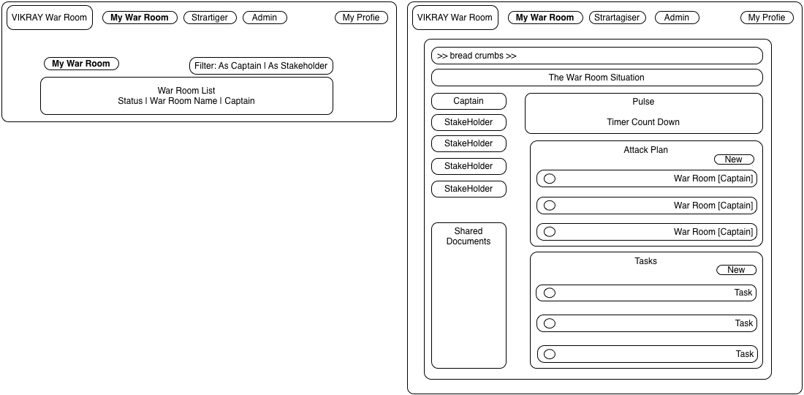

Wireframe – Strategiser

The organization can pre-define war rooms, define the triggers that will activate it and the respective stakeholders and assigned captain.

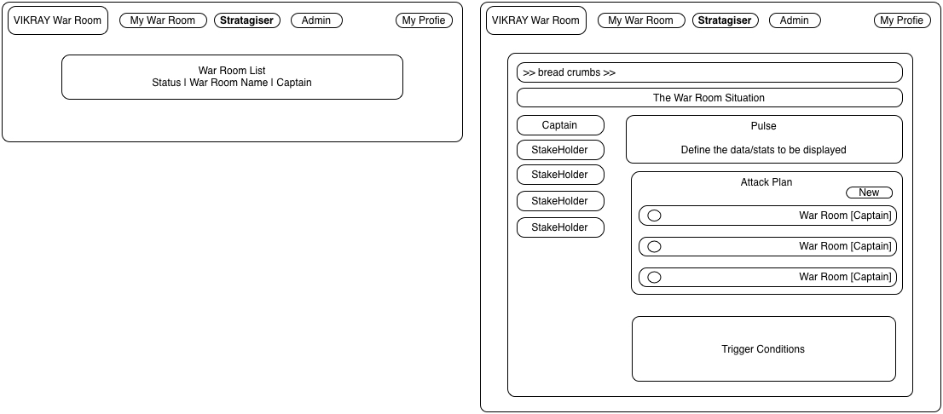

Data Model (First Level):
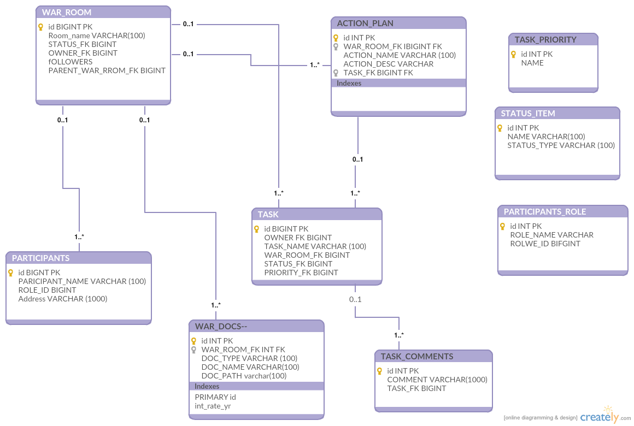

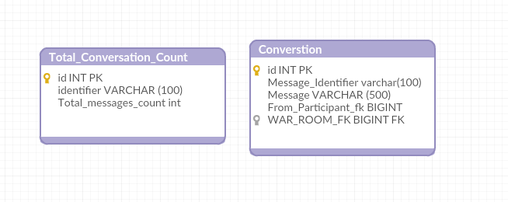
Example:
