From: Patel Nikhil [mailto:Patel.Nikhil@progilitytech.com]
Sent: Tuesday, May 29, 2018 4:30 PM
To: Ravi prasad
Cc: Rakesh Tank; Patel, Lopesh; Agravat, Jitesh
Subject: RE: Cisco 1750 with voice cards-URGENT-

Dear Mr.Ravi,

Pls find attached screen shot PO.

We will share signed PO to you within 2 days.

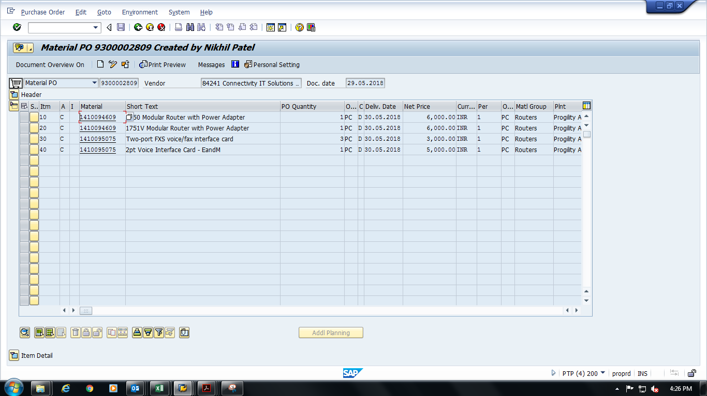

Regards,



Nikhil Patel
Progility Technologies Pvt. Ltd
409,4th Floor,Pinnacle,Business Park,Opp,Royal Orchid,Corporate Road,
Near Prahaldnagar, Ahmedabad 380015

Tel.: +91 079 40407507
Fax: +91 079 40407575
Cell: +91 9998129169

e-mail:patel.nikhil@progilitytech.com
website: www.progilitytech.com

Progility Technologies Pvt. Ltd
Registered office: 601, 6th Floor, 247 Park, Tower B, Vikhroli West, Mumbai 400083

