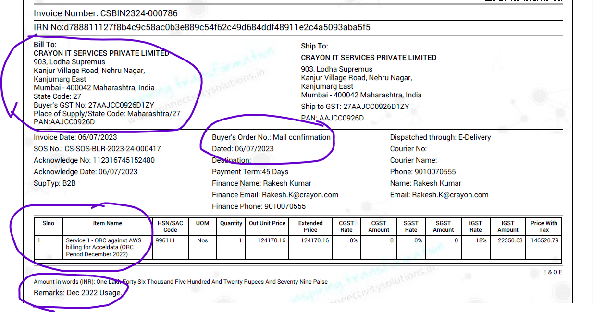

From: Kumari AP <ap.team@Connectivitysolutions.in>
Sent: Friday, March 15, 2024 7:21 PM
To: gangadhar M <gangadhar@cosol.in>; Madan P <madan@cosol.in>
Cc: Suhas J <suhas@cosol.in>
Subject: FW: Crayon and Connectivity Connects

Dear Gangadhar/Madan,

Please raise and share the invoice for the period April 2023 to Sept 2023 (generate one invoice – with multiple lines)

Duration | Consumption Value-INR | ORC Amount to Connectivity-INR- Equal Share
1st April 23 to 30th April 23 | 36,50,692 | 1,27,774
1st May to 31st May 2023 | 42,87,997 | 1,50,080
1st June to 30th June 2023 | 19,85,873 | 69,506
1st July to 31st July 2023 | 52,37,995 | 1,83,330
1st Aug to 31st Aug 2023 | 53,36,431 | 1,86,775
1st Sept to 31st Sept 2023 | 58,42,233 | 2,04,478
Grand Total | 3,28,96,909 | 9,21,943
Regards
Kumari
Accounts dept
Connectivity IT Solutions Pvt Ltd
8892942824

