OK…DONE

Regards,



Nikhil Patel
Progility Technologies Pvt. Ltd
409,4th Floor,Pinnacle,Business Park,Opp,Royal Orchid,Corporate Road,
Near Prahaldnagar, Ahmedabad 380015

Tel.: +91 079 40407507
Fax: +91 079 40407575
Cell: +91 9998129169

e-mail:patel.nikhil@progilitytech.com
website: www.progilitytech.com

Progility Technologies Pvt. Ltd
Registered office: 601, 6th Floor, 247 Park, Tower B, Vikhroli West, Mumbai 400083

From: Ravi prasad [mailto:ravi@connectivitysolutions.in]
Sent: Friday, December 21, 2018 4:02 PM
To: 'Patel Nikhil'; 'Rakesh Tank'; 'Agravat, Jitesh'; 'Patel, Lopesh'
Cc: 'gangadhar@connectivitysolutions.in'; 'avinash@connectivitysolutions.in'; 'logistics@connectivitysolutions.in'
Subject: RE: NM-HDV- CARD SALE-PROGILITY

Dear Sir ,

Greetings from Team Connectivity Solutions!

Please find attached amended saleq quote.

Note: I have shared quote for VWIC-2MFT-E1--@ Rs.4500/- + Tax inleiu of VWIC-1MFT-E1 as per your requirement with same cost of VWIC-1MFT-E1.

Please confirm immediatley to arrange for shipment today

Best Regards,
Ravi Prasad.K.
Office: +91 080 26716555
Mobile: +91 9844230252
ravi@connectivitysolutions.in
Bangalore | Mumbai | Chennai | Delhi | Singapore | USA




From: Patel Nikhil [mailto:Patel.Nikhil@progilitytech.com]
Sent: Friday, December 21, 2018 2:32 PM
To: Ravi prasad; Rakesh Tank; Agravat, Jitesh; Patel, Lopesh
Cc: gangadhar@connectivitysolutions.in; avinash@connectivitysolutions.in; logistics@connectivitysolutions.in
Subject: RE: NM-HDV- CARD SALE-PROGILITY

Dear Ravi,

PO # 9300005038/30

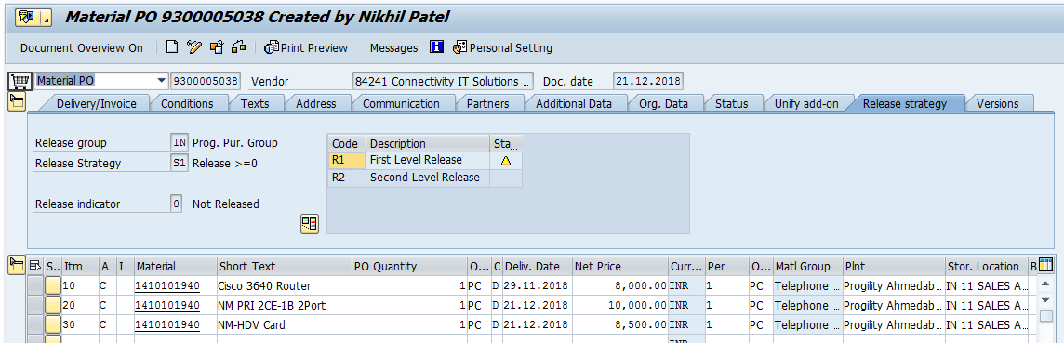

Regards,

Nikhil Patel
Progility Technologies Pvt. Ltd
409,4th Floor,Pinnacle,Business Park,Opp,Royal Orchid,Corporate Road,
Near Prahaldnagar, Ahmedabad 380015

Tel.: +91 079 40407507
Fax: +91 079 40407575
Cell: +91 9998129169

e-mail:patel.nikhil@progilitytech.com
website: www.progilitytech.com

